


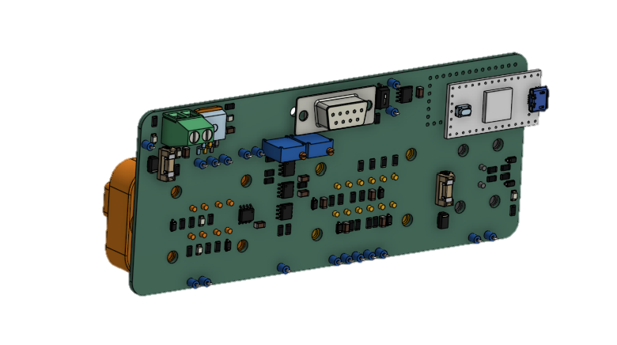
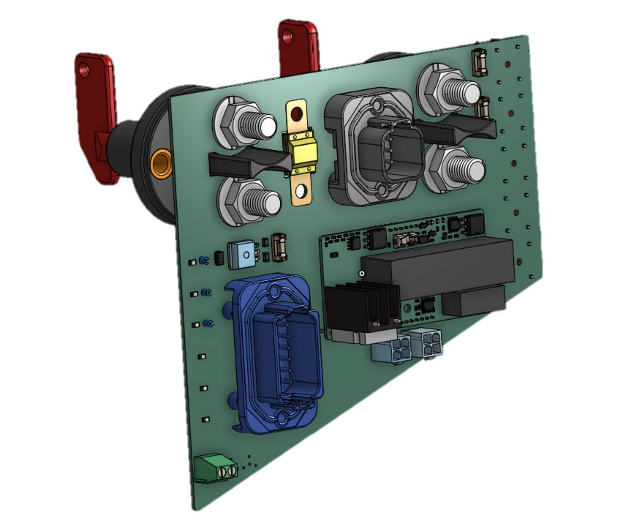
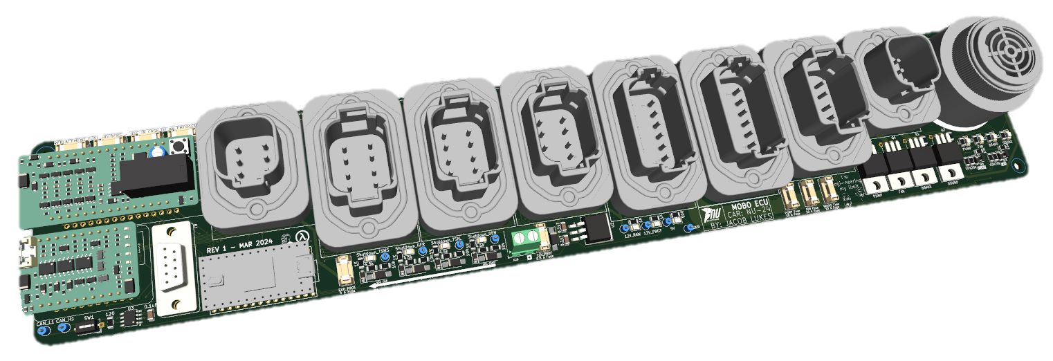
ZERO-TO-HERO

How To Import PCBs Into OnShape
Jacob Lukes
2025

Contents
Sanity Checks 2
How To Import PCB Into OnShape 2
How To Import PCBs Into an Assembly 8

Sanity Checks
- Firstly, ensure ALL step files for footprints are present and correctly positioned
  - This includes:
    - All dimensions for components are correct, mainly large components that protrude from the board. It is the PCB designer’s responsibility to know this
    - Checking that mating connectors and attached wires are accounted for
      - eg: Micro/Mini Fit MOLEX connectors that attach to the board in any way
      - This can be as simple as editing the original STEP file for the connector, and extruding it
  - Getting this part right saves LOTS of time down the line for the individual making the enclosure and the team as a whole
  - Refer to PCB Design Zero-To-Hero on how to make and attach STEP files to footprints

How To Import PCB Into OnShape
- From within KiCad, export the PCB as a STEP file
- Open OnShape, ensure you are in the correct NU Racing Project Folder for the given year (eg: NU-25)
  - You may need to gain access from the Mechanical Department Leader first before being allowed to complete the following steps
    - If you are not allowed access, please get the enclosure designer to read this document
- Navigate to the desired document (eg: LOW VOLTAGE)

- Select the plus button on the bottom left-hand side of the screen
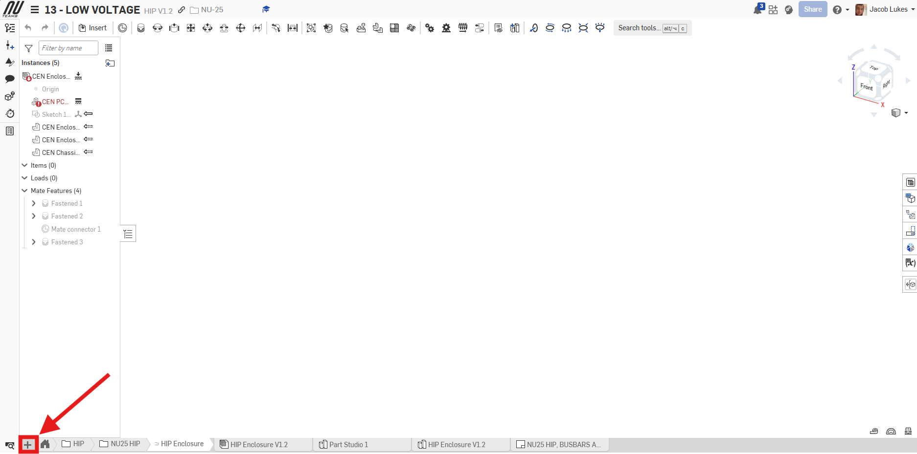
- Create a folder
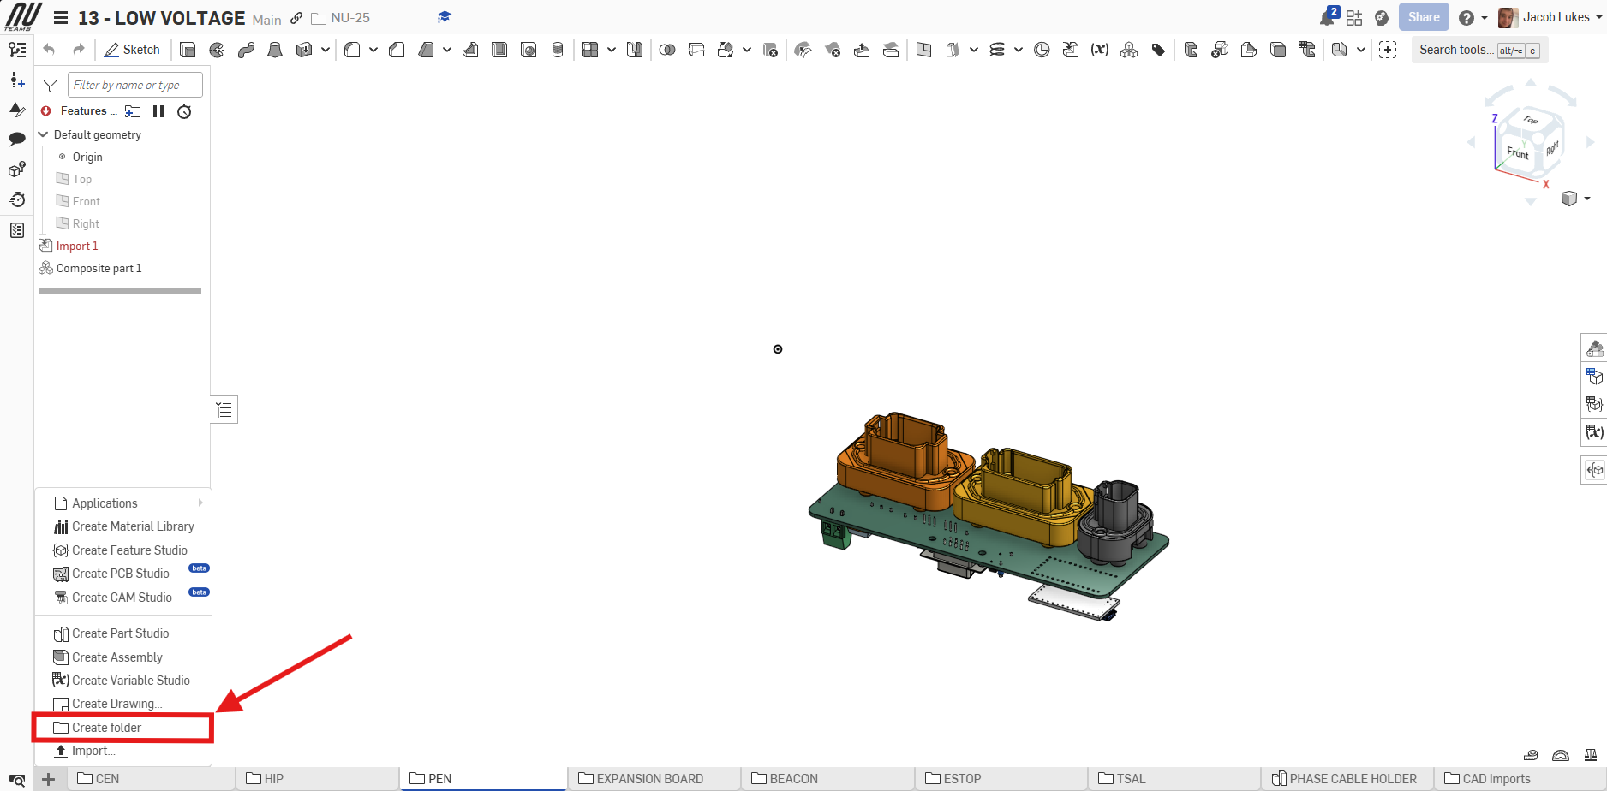

- Again select the plus button on the bottom left-hand side of the screen

- Select 'Import'
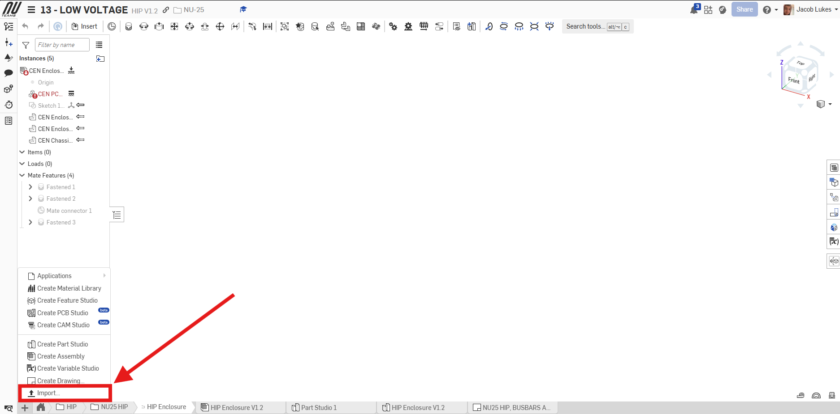

- Navigate to desired step file on PC
- Click 'Combine to a single Part Studio'
  - Tick:
    - 'Import appearances'
  - Untick:
    - 'Orient imported models with Y Axis Up'
    - 'Join adjacent surfaces'
- Click 'import'
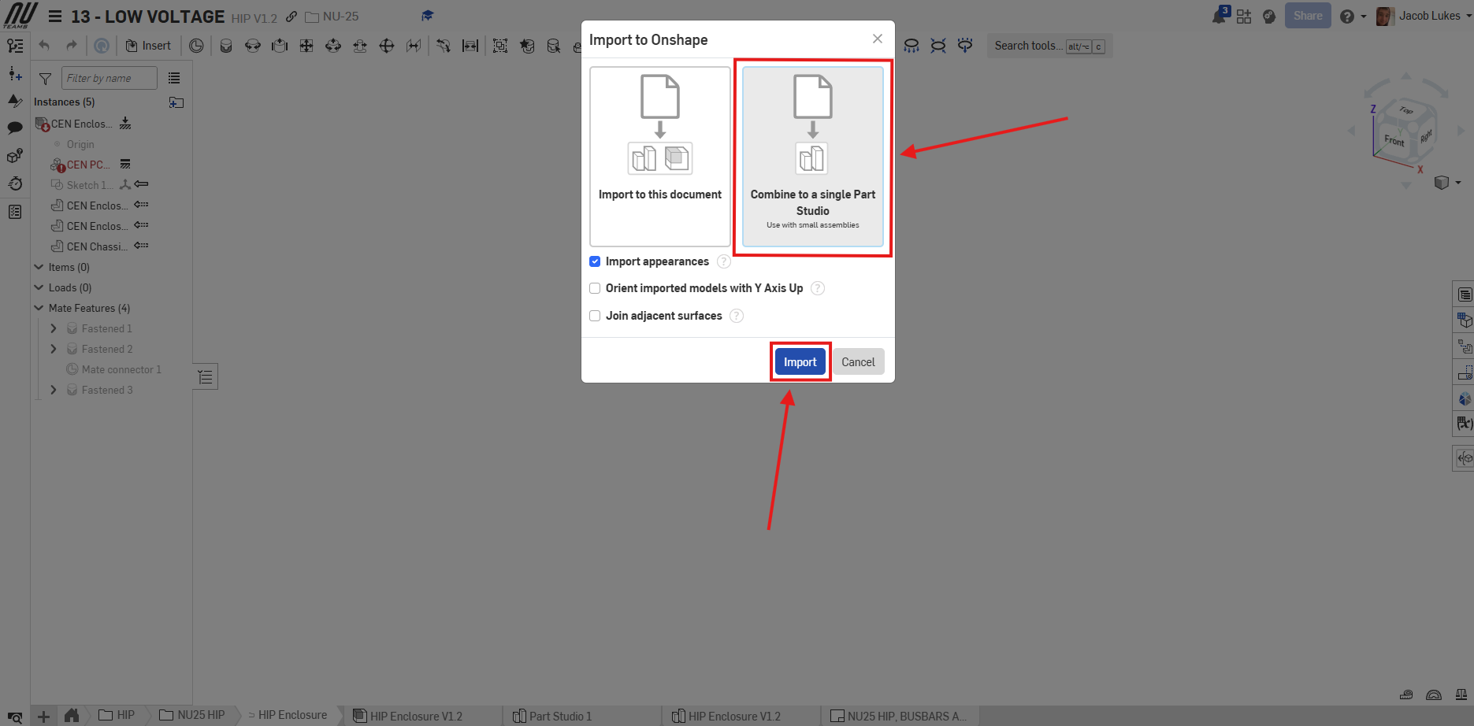
- Double click the imported part, usually 'Import 1's
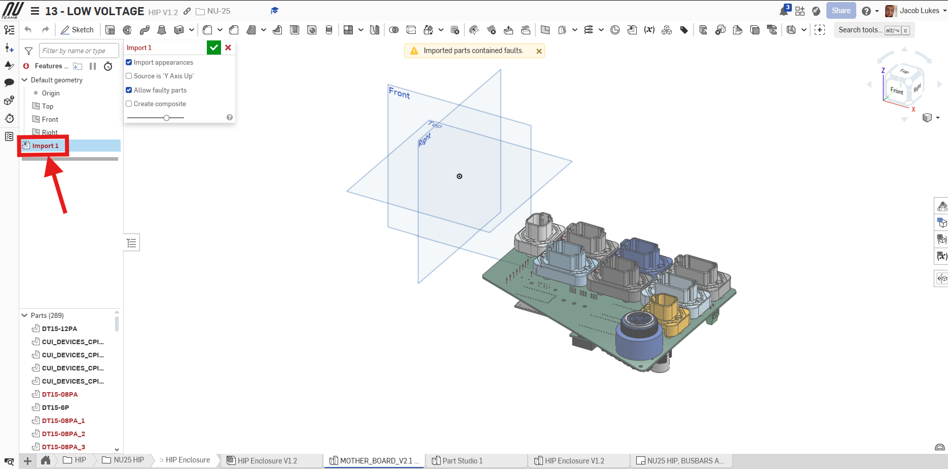
- Tick 'Create composite'
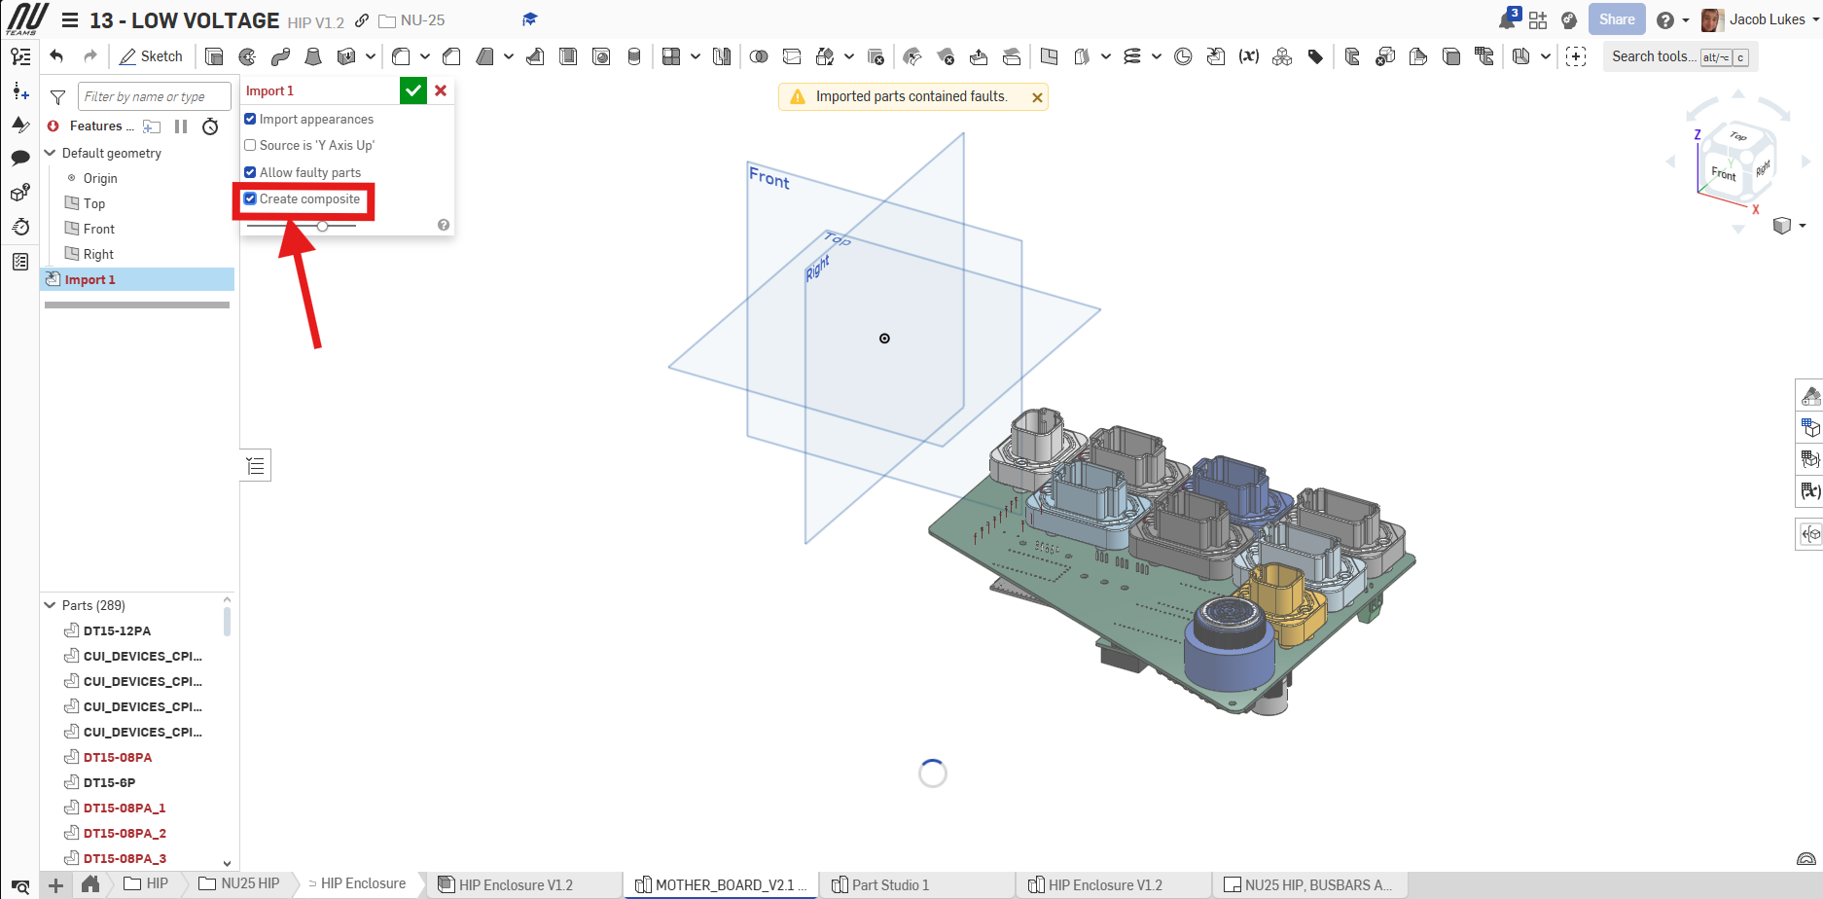
- Click the green check box
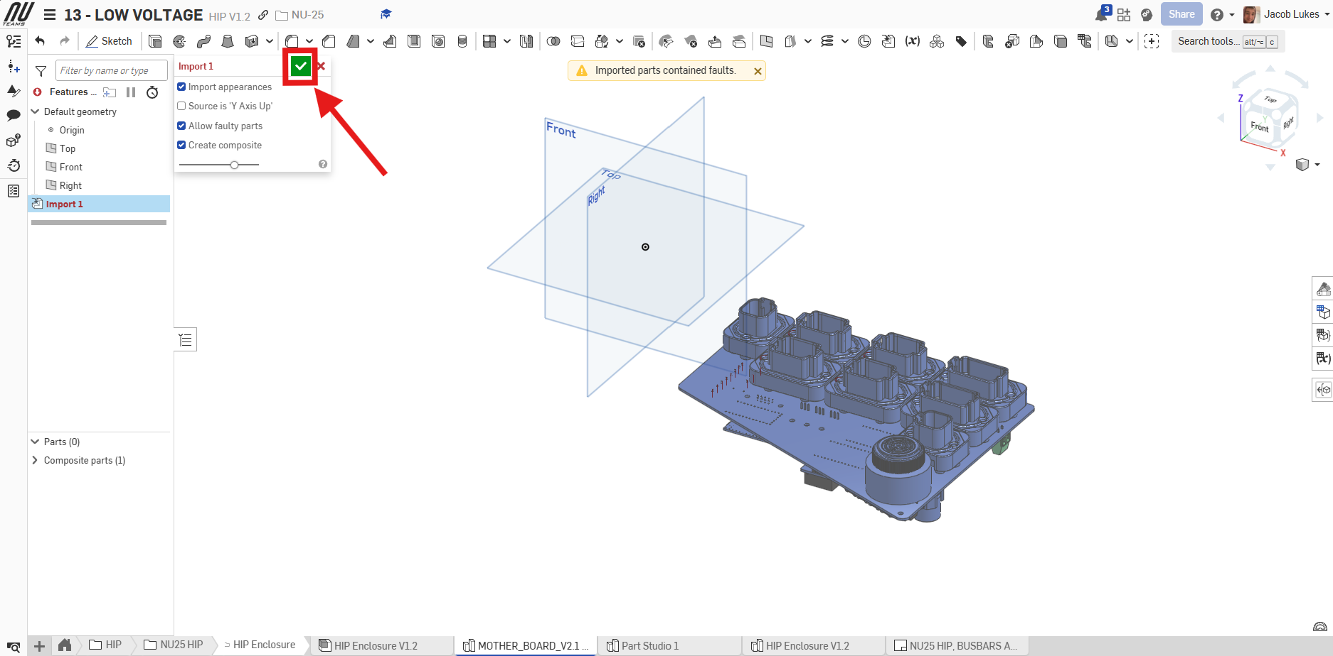
- Wait for it to think

- Ensure the composite part is the name of the given PCB
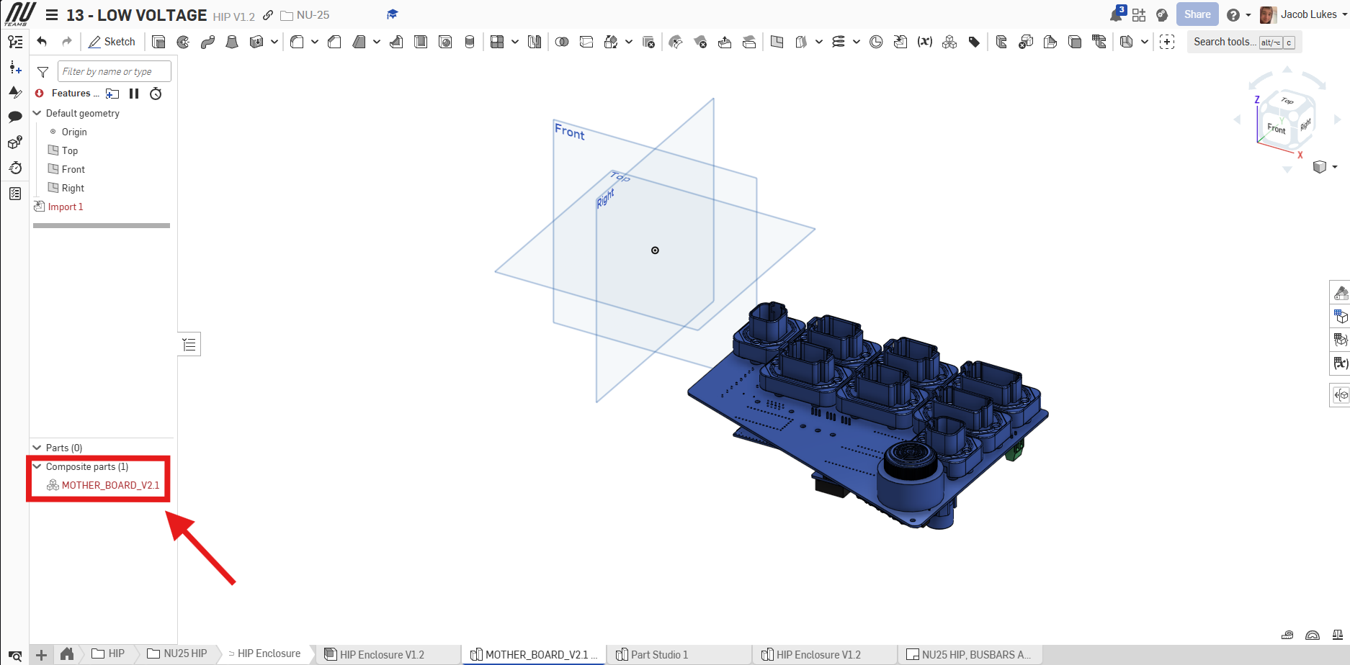
- Done!

How To Import PCBs Into an Assembly
- Only complete this section if requested by a member from the mechanical team
- Navigate to the desired Assembly
- Click 'Insert'
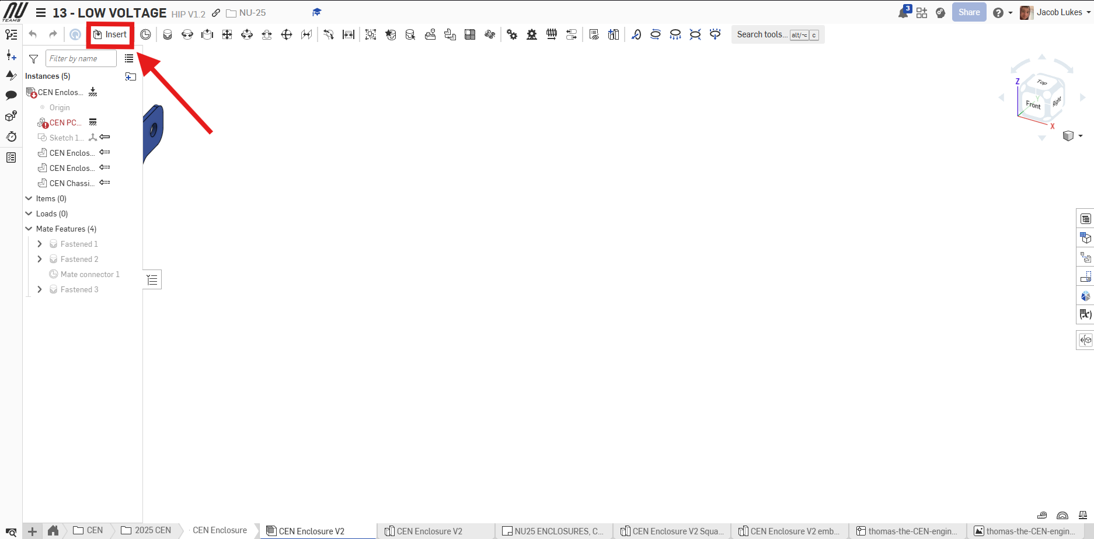
- Ensure to click 'Composite parts'
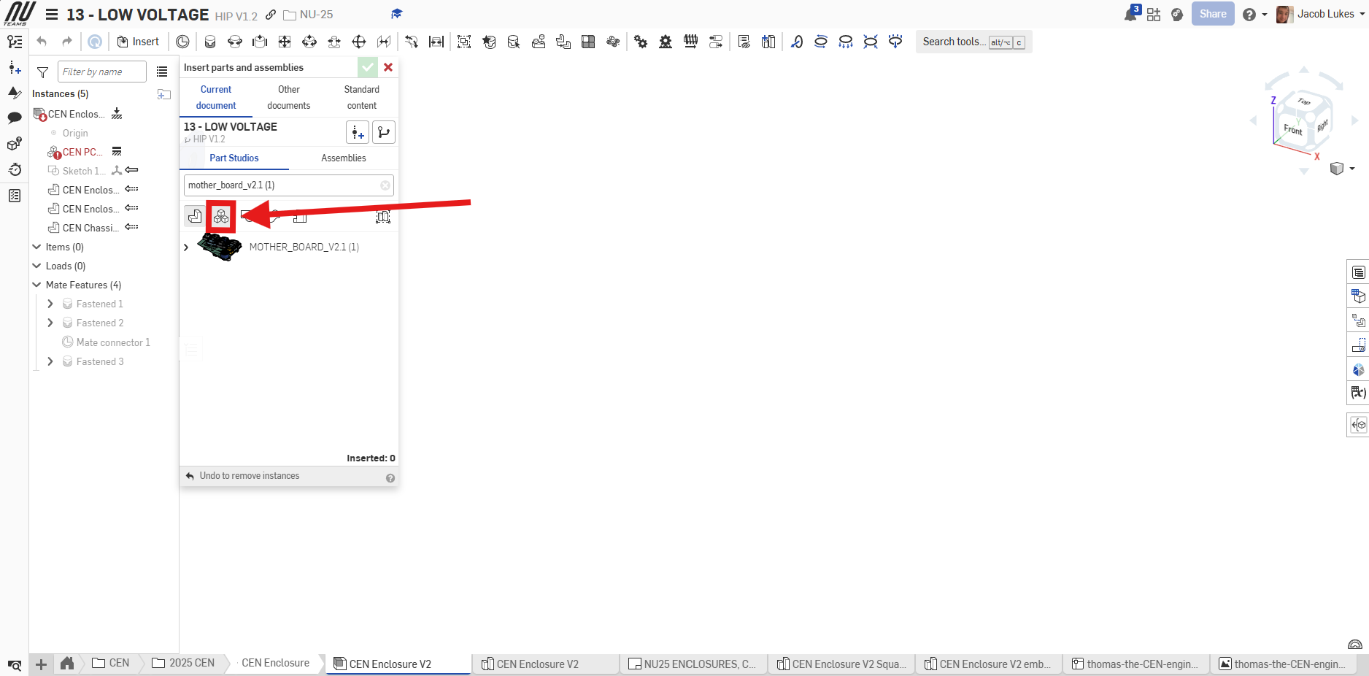
- Search for the desired PCB
- Clicking on the part will bring it into the Assembly

